**Practical Assignment - VII**

Ashutosh Jha (11811)

**Ques. 1:** Figure shows a bird in flight. Let the points along the top profile of the bird are given as:

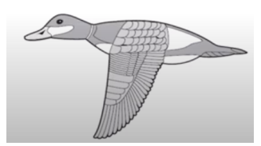

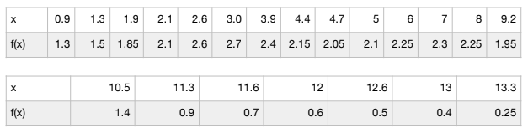

Approximate the curve corresponding to those points by using linear and Cubic Spline. Compare your results with Newton's Divided Difference Method.

**Sol. 1:**

**Linear Spline:**

**Program (using C++):**

#include<stdio.h>

void lSpline(int n, double x[n], double y[n], int N, double h, double X[N], double Y[N]){

int i;

int j=0;

**for**(i=0;i<n-1;i++){

//

double yn,xn;

**for**(xn=x[i];xn<x[i+1];xn=xn+h){

yn=(y[i+1]-y[i])*(xn-x[i])/(double)(x[i+1]-x[i])+y[i];

//yn=(xn-x[i+1])/(x[i]-x[i+1])+(xn-x[i])/(x[i+1]-x[i]);

Y[j]=yn;

X[j]=xn;

j++;

}

}

}

void main(){

int n = 21;

int N=0; //N is the no. of interpolated values

int i;

double h=0.1; //Space interval at which interpolated values are calculated

double x[] = {0.9, 1.3, 1.9, 2.1, 2.6, 3.0, 3.9, 4.4, 4.7, 5, 6, 7, 8, 9.2, 10.5, 11.3, 11.6, 12, 12.6, 13, 13.3};

double y[] = {1.3,1.5,1.85,2.1,2.6,2.7,2.4,2.15,2.05,2.1,2.25,2.3,2.25,1.95,1.4,0.9,0.7,0.6,0.5,0.4,0.25};

//The following procedure calculates N

**for**(i=0;i<n-1;i++){

N=N+(x[i+1]-x[i])/h;

}

//A little adjustment to get the correct value of N

N=N+2+(n-4);

printf("**\n**The no. of interpolated values N= %d**\n**",N);

double Y[N];

double X[N];

//Perform piecewise linear interpolation

lSpline(n,x,y,N,h,X,Y);

//Print the interpolated values in a File

**for**(i=0;i<N;i++){

printf("%lf**\t**%lf**\n**",X[i],Y[i]);

}

}

**Graph (Linear Spline):**

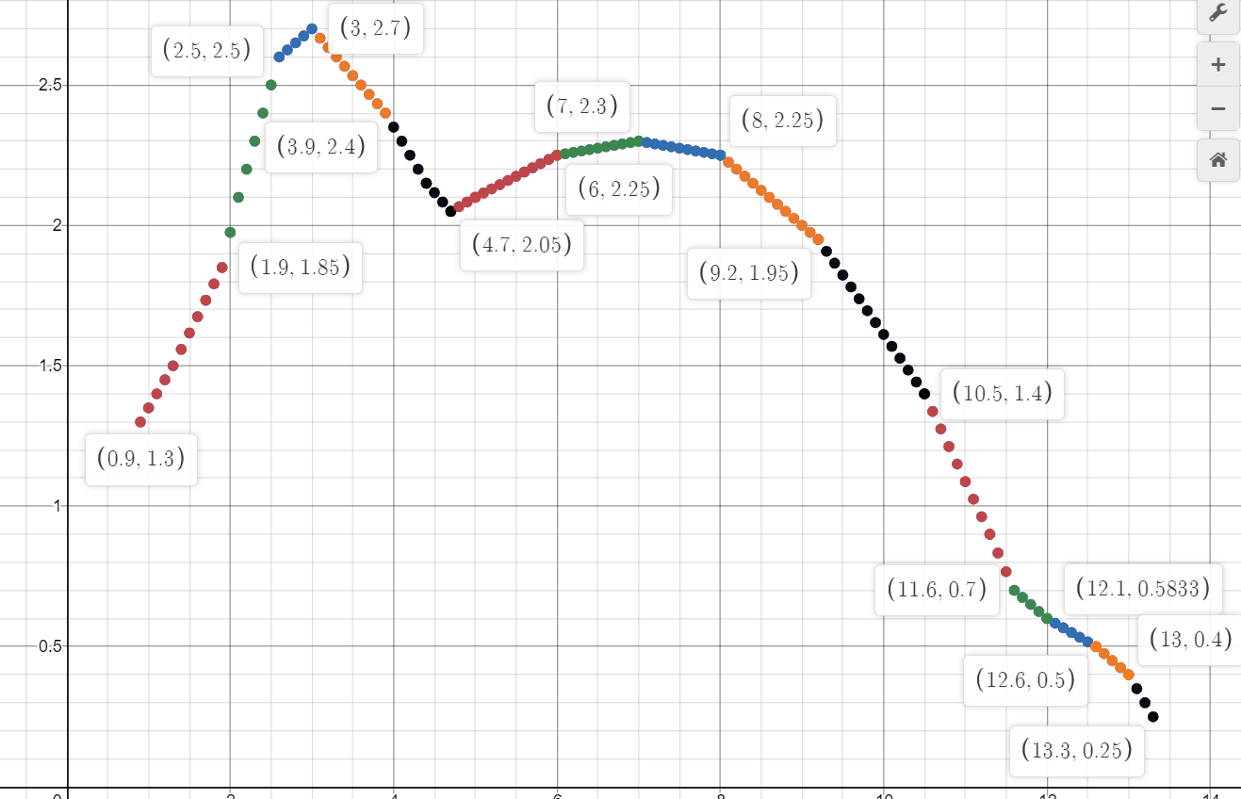

**Cubic Spline:**

**Program (using MATLAB):**

x = [**0.9** **1.3** **1.9** **2.1** **2.6** **3.0** **3.9** **4.4** **4.7** **5** **6** **7** **8** **9.2** **10.5** **11.3** **11.6** **12** **12.6** **13** **13.3**];

y = [**1.3** **1.5** **1.85** **2.1** **2.6** **2.7** **2.4** **2.15** **2.05** **2.1** **2.25** **2.3** **2.25** **1.95** **1.4** **0.9** **0.7** **0.6** **0.5** **0.4** **0.25**];

xx = **0.9**:.**2**:**13.3**;

yy = spline(x,y,xx);

disp(yy);

plot(x,y,'o',xx,yy)

**Graph (Cubic Spline):**

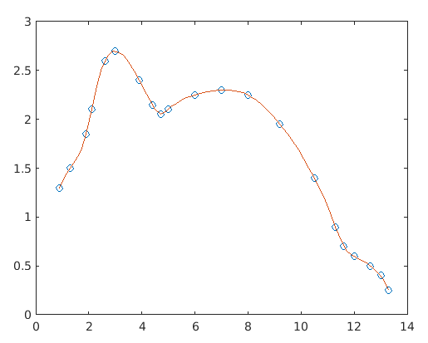

**Newton’s Divided Difference:**

**Program (using C++):**

#include <bits/stdc++.h>

**using** **namespace** std;

float proterm(int i, float value, float x[])

{

float pro = 1;

**for** (int j = 0; j < i; j++) {

pro = pro * (value - x[j]);

}

**return** pro;

}

void dividedDiffTable(float x[], float y[][21], int n)

{

**for** (int i = 1; i < n; i++) {

**for** (int j = 0; j < n - i; j++) {

y[j][i] = (y[j][i - 1] - y[j + 1]

[i - 1]) / (x[j] - x[i + j]);

}

}

}

float applyFormula(float value, float x[],

float y[][21], int n)

{

float sum = y[0][0];

**for** (int i = 1; i < n; i++) {

sum = sum + (proterm(i, value, x) * y[0][i]);

}

**return** sum;

}

void printDiffTable(float y[][21],int n)

{

**for** (int i = 0; i < n; i++) {

**for** (int j = 0; j < n - i; j++) {

cout << setprecision(4) <<

y[i][j] << " ";

}

cout << "**\n\n**";

}

}

int main()

{

int n = 21;

float value, sum, y[21][21];

float x[] = {0.9, 1.3, 1.9, 2.1, 2.6, 3.0, 3.9, 4.4, 4.7, 5, 6, 7, 8, 9.2, 10.5, 11.3, 11.6, 12, 12.6, 13, 13.3};

y[0][0] = 1.3 ;

y[1][0] = 1.5;

y[2][0] = 1.85;

y[3][0] = 2.1;

y[4][0] = 2.6;

y[5][0] = 2.7;

y[6][0] = 2.4;

y[7][0] = 2.15;

y[8][0] = 2.05;

y[9][0] = 2.1;

y[10][0] = 2.25;

y[11][0] = 2.3;

y[12][0] = 2.25;

y[13][0] = 1.95;

y[14][0] = 1.4;

y[15][0] = 0.9;

y[16][0] = 0.7;

y[17][0] = 0.6;

y[18][0] = 0.5;

y[19][0] = 0.4;

y[20][0] = 0.25;

dividedDiffTable(x, y, n);

printDiffTable(y,n);

**return** 0;

}

**Graph (Newton’s Divided Difference):**

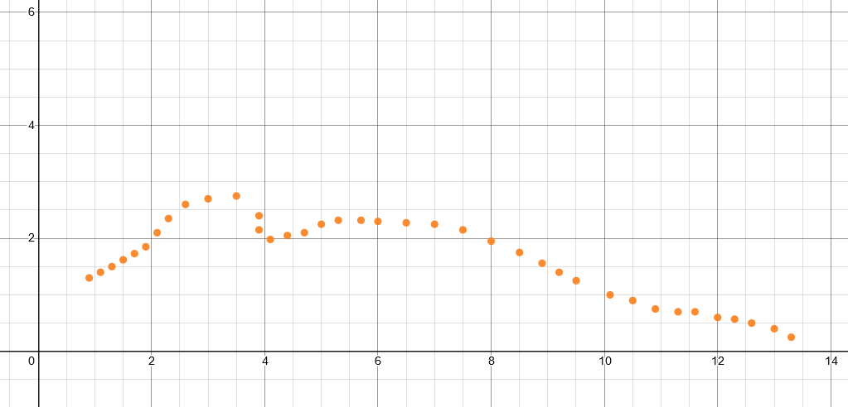

**Observation Table:**

| **x** | **f(x)** | **Newton's Divided Difference Method - Interpolating Polynomial** | **Linear Spline** | **Error (Newton - Linear Spline)** | **Cubic Spline** | **Error (Newton - Cubic Spline)** |
| --- | --- | --- | --- | --- | --- | --- |
| 0.9 | 1.3 | 1.3 | 1.3 | 0 | 1.3 | 0 |
| 1.1 | - | 1.4 | 1.4 | 0 | 1.4214 | -0.0214 |
| 1.3 | 1.5 | 1.5 | 1.5 | 0 | 1.5 | 0 |
| 1.5 | - | 1.62 | 1.616667 | 0.003333 | 1.5729 | 0.0471 |
| 1.7 | - | 1.73 | 1.733333 | -0.003333 | 1.6772 | 0.0528 |
| 1.9 | 1.85 | 1.85 | 1.85 | 0 | 1.85 | 0 |
| 2.1 | 2.1 | 2.1 | 2.1 | 0 | 2.1 | 0 |
| 2.3 | - | 2.35 | 2.3 | 0.05 | 2.3404 | 0.0096 |
| 2.5 | - | 2.5 | 2.5 | 0 | 2.5306 | -0.0306 |
| 2.7 | - | 2.69 | 2.625 | 0.065 | 2.6495 | 0.0405 |
| 2.9 | - | 2.7 | 2.675 | 0.025 | 2.6968 | 0.0032 |
| 3.1 | - | 2.6 | 2.666667 | -0.066667 | 2.6929 | -0.0929 |
| 3.3 | - | 2.67 | 2.6 | 0.07 | 2.6528 | 0.0172 |
| 3.5 | - | 2.75 | 2.533333 | 0.216667 | 2.585 | 0.165 |
| 3.7 | - | 2.54 | 2.466667 | 0.073333 | 2.498 | 0.042 |
| 3.9 | 2.4 | 2.4 | 2.4 | 0 | 2.4 | 0 |
| 4.1 | - | 1.98 | 2.3 | -0.32 | 2.2987 | -0.3187 |
| 4.3 | - | 2 | 2.2 | -0.2 | 2.1985 | -0.1985 |
| 4.5 | - | 2.11 | 2.116667 | -0.006667 | 2.1045 | 0.0055 |
| 4.7 | 2.05 | 2.05 | 2.05 | 0 | 2.05 | 0 |
| 4.9 | - | 2.0824 | 2.083333 | -0.000933 | 2.0738 | 0.0086 |
| 5.1 | - | 2.123 | 2.115 | 0.008 | 2.1247 | -0.0017 |
| 5.3 | - | 2.32 | 2.145 | 0.175 | 2.1659 | 0.1541 |
| 5.5 | - | 2.27 | 2.175 | 0.095 | 2.1977 | 0.0723 |
| 5.7 | - | 2.32 | 2.205 | 0.115 | 2.2223 | 0.0977 |
| 5.9 | - | 2.28 | 2.235 | 0.045 | 2.2416 | 0.0384 |
| 6.1 | - | 2.294 | 2.255 | 0.039 | 2.2578 | 0.0362 |
| 6.3 | - | 2.301 | 2.265 | 0.036 | 2.2718 | 0.0292 |
| 6.5 | - | 2.275 | 2.275 | 0 | 2.2833 | -0.0083 |
| 6.7 | - | 2.203 | 2.285 | -0.082 | 2.2921 | -0.0891 |
| 6.9 | - | 2.214 | 2.295 | -0.081 | 2.2981 | -0.0841 |
| 7.1 | - | 2.245 | 2.295 | -0.05 | 2.301 | -0.056 |
| 7.3 | - | 2.219 | 2.285 | -0.066 | 2.3001 | -0.0811 |
| 7.5 | - | 2.15 | 2.275 | -0.125 | 2.2942 | -0.1442 |
| 7.7 | - | 2.13 | 2.265 | -0.135 | 2.2822 | -0.1522 |
| 7.9 | - | 2.11 | 2.255 | -0.145 | 2.2628 | -0.1528 |
| 8.1 | - | 2.1 | 2.225 | -0.125 | 2.235 | -0.135 |
| 8.3 | - | 1.98 | 2.175 | -0.195 | 2.1986 | -0.2186 |
| 8.5 | - | 1.75 | 2.125 | -0.375 | 2.1543 | -0.4043 |
| 8.7 | - | 1.61 | 2.075 | -0.465 | 2.1031 | -0.4931 |
| 8.9 | - | 1.56 | 2.025 | -0.465 | 2.0457 | -0.4857 |
| 9.1 | - | 1.83 | 1.975 | -0.145 | 1.9831 | -0.1531 |
| 9.3 | - | 1.51 | 1.907692 | -0.397692 | 1.9159 | -0.4059 |
| 9.5 | - | 1.25 | 1.823077 | -0.573077 | 1.8444 | -0.5944 |
| 9.7 | - | 1.15 | 1.738462 | -0.588462 | 1.7679 | -0.6179 |
| 9.9 | - | 1.03 | 1.653846 | -0.623846 | 1.6858 | -0.6558 |
| 10.1 | - | 1 | 1.569231 | -0.569231 | 1.5975 | -0.5975 |
| 10.3 | - | 1 | 1.484615 | -0.484615 | 1.5025 | -0.5025 |
| 10.5 | 1.4 | 1.4 | 1.4 | 0 | 1.4 | 0 |
| 10.7 | - | 1.21 | 1.275 | -0.065 | 1.2894 | -0.0794 |
| 10.9 | - | 0.75 | 1.15 | -0.4 | 1.1699 | -0.4199 |
| 11.1 | - | 0.82 | 1.025 | -0.205 | 1.0404 | -0.2204 |
| 11.3 | 0.9 | 0.9 | 0.9 | 0 | 0.9 | 0 |
| 11.5 | - | 0.743 | 0.766667 | -0.023667 | 0.7575 | -0.0145 |
| 11.7 | - | 0.701 | 0.675 | 0.026 | 0.6592 | 0.0418 |
| 11.9 | - | 0.613 | 0.625 | -0.012 | 0.6142 | -0.0012 |
| 12.1 | - | 0.574 | 0.583333 | -0.009333 | 0.5856 | -0.0116 |
| 12.3 | - | 0.57 | 0.55 | 0.02 | 0.5538 | 0.0162 |
| 12.5 | - | 0.49 | 0.516667 | -0.026667 | 0.5187 | -0.0287 |
| 12.7 | - | 0.472 | 0.475 | -0.003 | 0.4804 | -0.0084 |
| 12.9 | - | 0.4321 | 0.425 | 0.0071 | 0.4322 | -0.0001 |
| 13.1 | - | 0.318 | 0.35 | -0.032 | 0.3601 | -0.0421 |
| 13.3 | 0.25 | 0.25 | 0.25 | 0 | 0.25 | 0 |

**Error Graph (Linear Spline):**

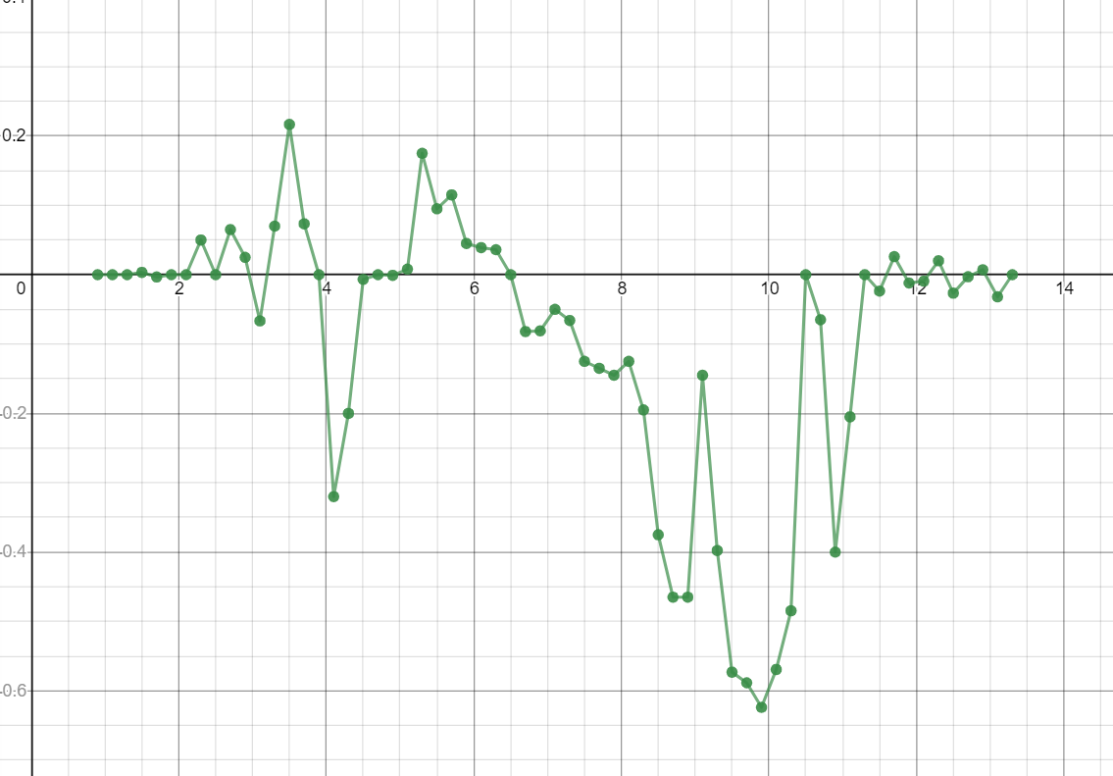

**Error Graph (Cubic Spline):**

